*** York County Audubon announces Hog Island Scholarship ***
For July, 2018 Program
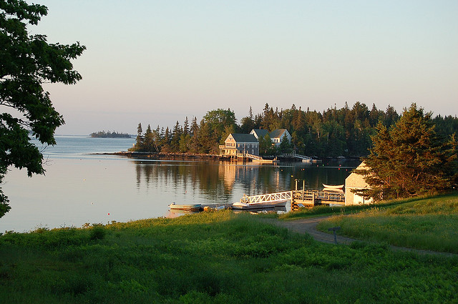
York County Audubon Society (YCAS) is seeking an educator or community leader to participate in a one-week program on famed Hog Island off mid-coast Maine in July 2018. YCAS will sponsor one participant who can benefit from the Hog Island experience and use it to teach others. Complete information is available at www.yorkcountyaudubon.org and applications are due by March 15, 2018.
The program is entitled “Sharing Nature: An Educator’s Week” and will run from July 15th through July 20th. Program details and descriptions are available at http://hogisland.audubon.org/sharing-nature-educator-s-week. The YCAS scholarship will pay 70% of the recipient's cost for program tuition, room and board.
YCAS’s 2017 Hog Island scholarship winner was teacher Noel Leigh (Margaret Chase Smith School). She described her program experience in an article for the Autumn 2017 issue of The Harlequin, which can be accessed through the YCAS website. And a report from our 2016 winner, Katie Brodeur (from the Center for Wildlife) can be found in the Autumn 2016 issue.
Since 1936, some of the world’s most well-known and highly respected naturalists have come to Hog Island and inspired thousands to learn about and protect birds and the environment. Roger Tory Peterson was among the first teachers on the 335-acre island. Rachel Carson described her visit to Hog Island in her landmark book, Silent Spring. Kenn Kaufman, only nine years old when he read Peterson’s account of Hog lsland, is now an international authority on birds and nature.
York County Audubon Society fosters understanding, appreciation, and conservation of the natural world through the education of present and future generations. This Hog Island scholarship is dedicated to June Ficker, bird bander extraordinaire, who shared her love for birds with thousands of York County residents and visitors. YCAS is a chapter of Maine Audubon.

