Maine Young Birders Club announces Hog Island Scholarships
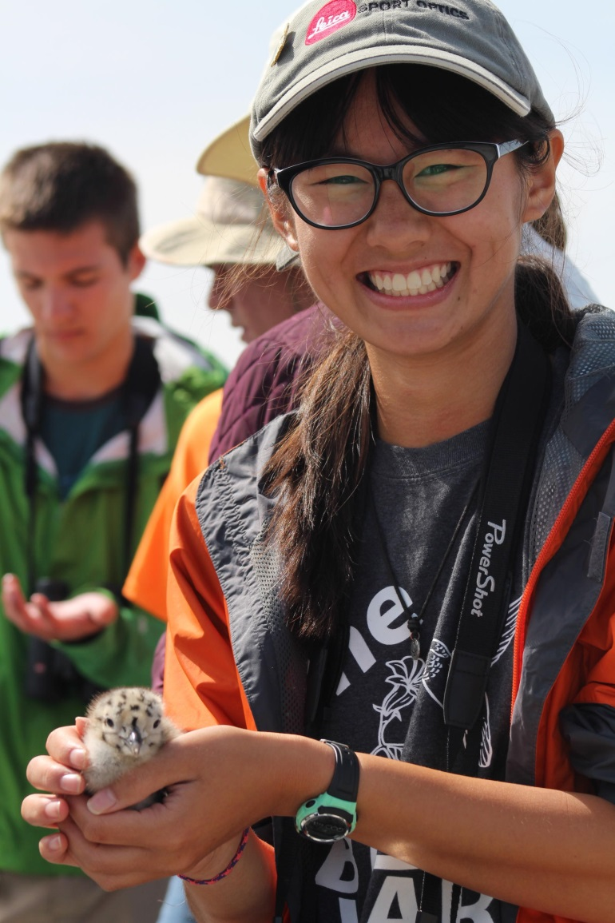
For June, 2020 Teen Birders Program

The Maine Young Birders Club (MYBC) is seeking a teen (age 14-17) to participate in a one-week program on famed Hog Island off mid-coast Maine in June 2020. Working with York County Audubon and Friends of Hog Island, MYBC will select and sponsor a teen who can benefit from the Hog Island experience and pass it forward to others. Complete information is available at www.yorkcountyaudubon.org/scholarships. Applications are due by March 15, 2020.
The program is entitled “Coastal Maine Bird Studies for Teens” and will run from June 21st through June 26th. Program details and descriptions are available at http://hogisland.audubon.org/bird-studies-teens. The MYBC scholarships will pay 100% of $1395 cost for tuition, room and board.
Since 1936, some of the world’s most well-known and highly respected naturalists have come to Hog Island and inspired thousands to learn about and protect birds and the environment. Roger Tory Peterson was among the first teachers on the 335-acre island. Rachel Carson described her visit to Hog Island in her landmark book, Silent Spring. Kenn Kaufman, only nine years old when he read Peterson’s account of Hog lsland, is now an international authority on birds and nature.

The Maine Young Birders Club (which is sponsored by York County Audubon) provides a safe environment for youth in Maine to experience the wonder of birds and nature with other teens through birding-related events and activities, and promotes engagement with our natural world by empowering young Maine residents to study and enjoy birds and birding. For more information on the MYBC, please visit our website: www.maineyoungbirders.org

