York County Audubon announces Hog Island Educator’s Scholarship
For July, 2024 Program
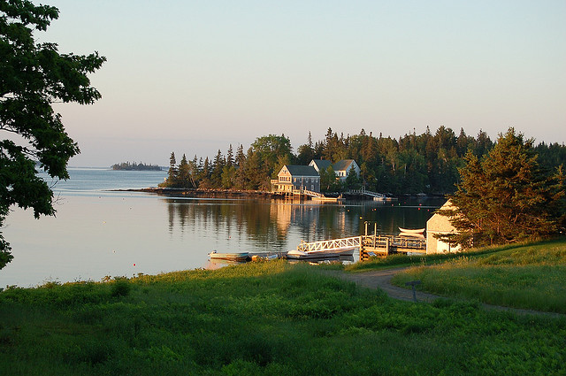
York County Audubon (YCA) is seeking an educator or community leader to participate in a one-week program on famed Hog Island off mid-coast Maine in July 2024. YCA will sponsor one participant who can benefit from the Hog Island experience and use it to teach others. Complete information is available at www.yorkcountyaudubon.org/scholarships and applications are due by Monday, March 11, 2024.
The program is entitled “Sharing Nature: An Educator’s Week” and will run from July 14th through July 19th. Program details and descriptions are available at http://hogisland.audubon.org/sharing-nature-educator-s-week. The YCA scholarship will pay 70% of the recipient's cost for program tuition, room and board.
Since 1936, some of the world’s most well-known and highly respected naturalists have come to Hog Island and inspired thousands to learn about and protect birds and the environment. Roger Tory Peterson was among the first teachers on the 335-acre island. Rachel Carson described her visit to Hog Island in her landmark book, Silent Spring. Kenn Kaufman, only nine years old when he read Peterson’s account of Hog lsland, is now an international authority on birds and nature.
YCAS’s 2023 June Ficker Hog Island Educator’s Scholarship winner was Christine Durocher who teaches seventh grade science at Wells Junior High School. She described her program experience in an article for the Autumn 2023 issue of The Harlequin, which can be accessed through the YCA website. Reports from prior years’ winners can be found in previous Autumn issues of The Harlequin on our website.
York County Audubon fosters understanding, appreciation, and conservation of the natural world through the education of present and future generations. This Hog Island scholarship is dedicated to June Ficker, bird bander extraordinaire, who shared her love for birds with thousands of York County residents and visitors. YCA is a chapter of Maine Audubon.

