York County Audubon announces Coastal Maine Bird Studies for Teens Scholarship for June 2026 Program
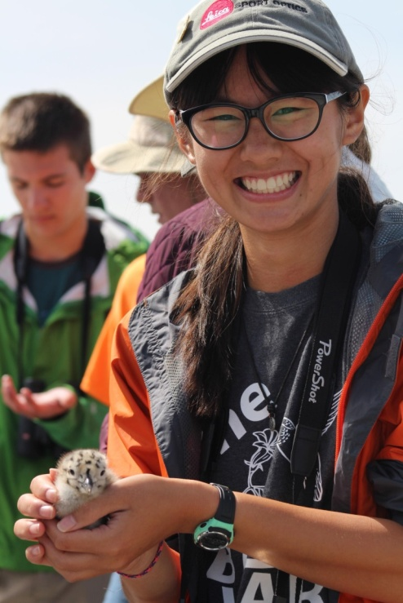
The Maine Young Birders Club (MYBC), in partnership with York County Audubon and Friends of Hog Island, is excited to announce a scholarship opportunity for a young birder to attend the Coastal Maine Bird Studies for Teens program on Hog Island in June 2026. The scholarship will cover 100% of the recipient’s cost to attend this renowned birding program.
The Coastal Maine Bird Studies for Teens program is an immersive, 6-day, 5-night experience taking place from June 21 through June 26, 2026. This opportunity allows passionate young birders to work alongside some of the country's leading birders and ornithologists, learning about field identification, bird ecology, and conservation. The program offers hands-on experience with Audubon’s seabird restoration efforts and a visit to Eastern Egg Rock to observe puffins during their breeding season (weather and sea conditions permitting).
The scholarship application, along with complete program details and instructions, is available at https://www.maineyoungbirders.org/scholarships. The application deadline is Wednesday, February 18, 2026. Applicants must be between the ages of 14 and 17 to apply. In return for this scholarship, the recipient will be asked to submit a short summary of their trip and the lessons learned.
For full program details, please visit https://hogisland.audubon.org/programs/bird-studies-teens.
The Maine Young Birders Club aims to provide a safe and supportive environment for teens in Maine to explore birds and nature through birding-related events and activities. MYBC encourages young people to develop a deep connection with the natural world by empowering them to study and enjoy birds.

